**CN LAB TEST 2**

**Objective:**

To set up and configure two LANs connected via two routers using RIP and OSPF routing protocols, forming a WAN. The configuration includes IP address assignment based on the last three digits of the roll number and testing communication between the LANs.

**Procedure:**

**Network Design:**

1. **Router1 connected to Router2**:
   * Create a network topology with **10 computers** divided into two LANs.
   * **PC0, PC1, PC2, PC3, PC4** connected to **Switch1** in LAN 1.
   * **PC5, PC6, PC7, PC8, PC9** connected to **Switch2** in LAN 2.
   * **Switch1** connected to **Router1**.
   * **Switch2** connected to **Router2**.
   * **Router1** and **Router2** connected via a WAN link.

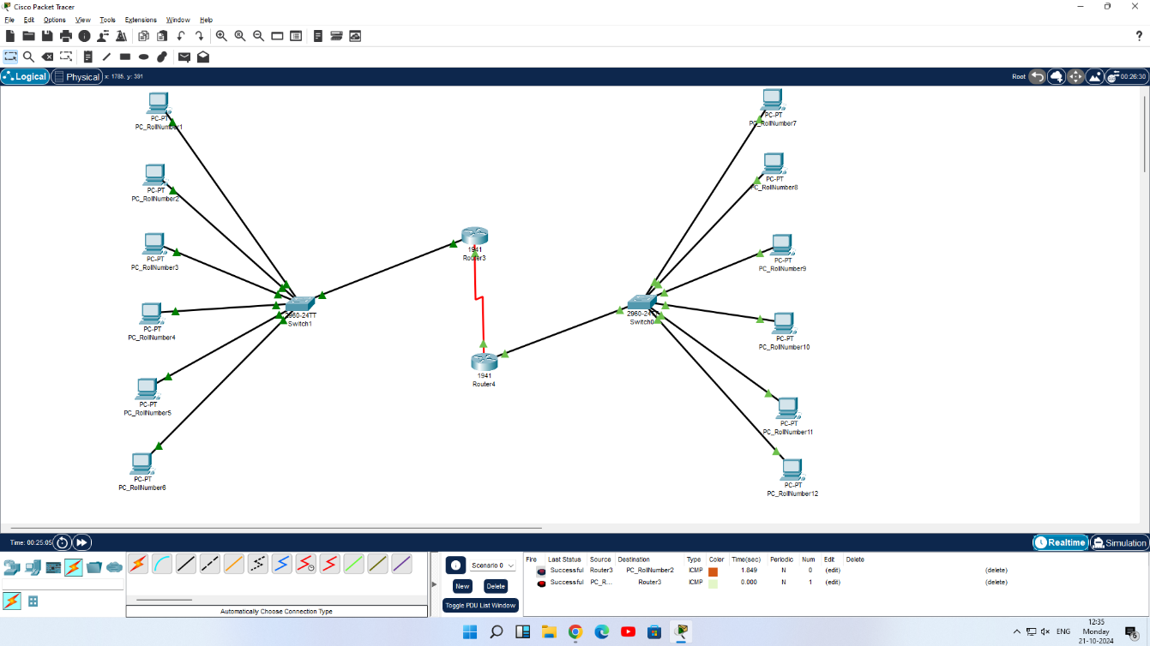

**Step 1: IP Address Scheme**

1. Assign **IP addresses** based on the following scheme:
   * **LAN 1:** 192.168.1.0/24
   * **LAN 2:** 192.168.2.0/24
   * **Router1 to Router2 WAN Link:** 10.0.0.0/30

**Step 2: Configuring Router1 (RIP Protocol)**

1. **Select Router1** and open the CLI.
2. Press **ENTER** to start configuring.
3. **Activate privileged mode**
4. **Access the configuration menu**
5. **Configure the FastEthernet0/0 interface** connected to **LAN 1**
6. **Configure the Serial 0/0/0 interface** for the **WAN link** to Router2
7. **Configure RIP v1** for Router1

**Step 3: Configuring Router2 (OSPF Protocol)**

1. **Select Router2** and open the CLI
2. Press **ENTER** to start configuring.
3. **Activate privileged mode**
4. **Access the configuration menu**
5. **Configure the FastEthernet0/0 interface** connected to **LAN 2**
6. **Configure the Serial 0/0/0 interface** for the **WAN link** to Router1
7. **Configure OSPF** for Router2

**Step 4: Configuring PCs**

* **Assign IP addresses to each PC in LAN 1 (Switch1):**
  + **PC0:**
    - IP Address: 192.168.1.2
    - Subnet Mask: 255.255.255.0
    - Default Gateway: 192.168.1.1
  + **PC1 to PC4**: Use IPs 192.168.1.3 to 192.168.1.6 with the same Subnet Mask and Default Gateway.
* **Assign IP addresses to each PC in LAN 2 (Switch2):**
  + **PC5:**
    - IP Address: 192.168.2.2
    - Subnet Mask: 255.255.255.0
    - Default Gateway: 192.168.2.1
  + **PC6 to PC9**: Use IPs 192.168.2.3 to 192.168.2.6 with the same Subnet Mask and Default Gateway.

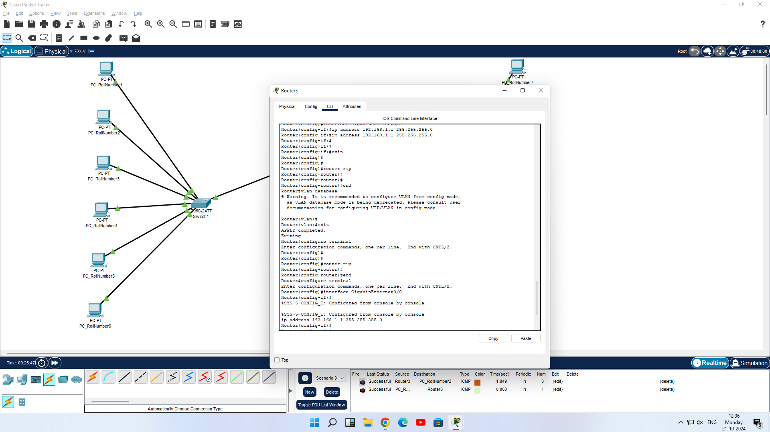

**Step 5: Verify Connectivity**

1. **Ping test between LAN 1 and LAN 2:**
   * From **PC0** in **LAN 1**, open the command prompt and type:

ping 192.168.2.2

* + From **PC5** in **LAN 2**, open the command prompt and type:

ping 192.168.1.2

1. **Verify that the packets are successfully transmitted** and the connectivity between LAN 1 and LAN 2 is established.

**Step 6: Check Message Passing**

1. **Open Simulation Mode** in **Cisco Packet Tracer**.
2. **Select PC0** in **LAN 1**:
   * Go to the **Desktop** tab, open the **Command Prompt**, and type:

ping 192.168.2.2

* + This will send a message from **PC0** to **PC5** in **LAN 2**.

1. **Switch to Simulation Mode** and **Run** the simulation:
   * Watch the packet being transmitted from **PC0** through **Router1** to **Router2**, and finally to **PC5**.
2. Once the message reaches **PC5**, a **reply packet** will be sent back to **PC0**.
   * This confirms that the network is functioning properly and that messages can successfully pass between the two LANs.
3. **Check for Success**:
   * If the **ping** is successful, you will see the message:

Reply from 192.168.2.2: bytes=32 time<1ms TTL=128

* + This indicates that the message has been successfully sent and acknowledged, verifying connectivity across the LANs.

